Name _______________________ Date __________
Heat

We will need:
3 glass jars
Tape for labeling jars
3 different colors of food color (blue, green, red)
500 milliliters Water - cold
500 milliliters Water – room temperature
500 milliliters Water – Hot

Procedure:
Write down your hypothesis – What do you think will happen?
Label each jar – Cold, Room Temperature, Hot
Pour 500 ml of each temperature of water in the appropriate jar
Place 3 drops of blue food coloring in the cold jar.
Place 3 drops of green food coloring in the room temperature jar.
Place 3 drops of red food coloring in the hot jar.
Draw and write your observations

Hypothesis – What do you think will happen?

__________________________________________________________________________________________

__________________________________________________________________________________________

Observations:
Draw it
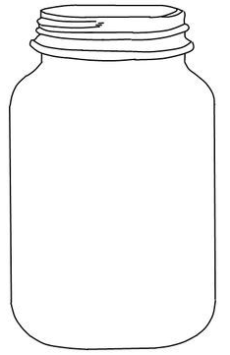

Write about it:

__________________________________________________________________________________________

__________________________________________________________________________________________

Conclusion – Why do you think this happened?

__________________________________________________________________________________________

__________________________________________________________________________________________

