Name _______________________ Date __________
Humidity

We will need:
We will need:
3 glass jars
3 x 500 milliliters hot water
3 pieces of plastic wrap
Ice
1 sponge soaked in hot water

Procedure:
Write your hypothesis – What do you think will happen.
Put 500 ml of hot water in each glass jar.
Cover each jar with plastic wrap.
On the first jar, place some the sponge.
Leave the second jar with nothing on top.
On the third jar, place some ice.
Wait and observe
Record your observations on your humidity activity sheet.

Hypothesis – What do you think will happen?

__________________________________________________________________________________________

__________________________________________________________________________________________

Observations:
Draw it
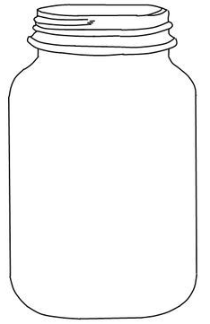

Write about it:

__________________________________________________________________________________________

__________________________________________________________________________________________

Conclusion – Why do you think this happened?

__________________________________________________________________________________________

__________________________________________________________________________________________

