Weather | The conditions in the air above the Earth such as wind, Rain and temperature
Temperature | A measurement of heat
Thermometer | 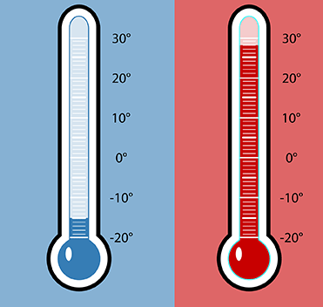
Heat | A form of energy that a substance has because of the movement of it’s atoms or molecules.
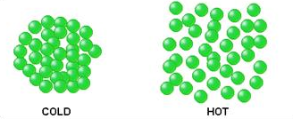 | Humidity
A measurement of how wet the air is. | Hygrometer
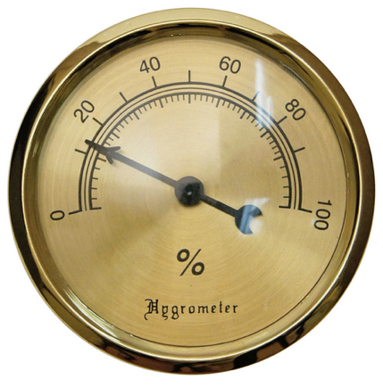 | Water  Vapor
Air  Pressure | 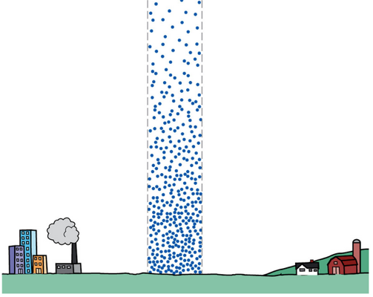
The weight of air molecules pressing down on Earth | Barometer
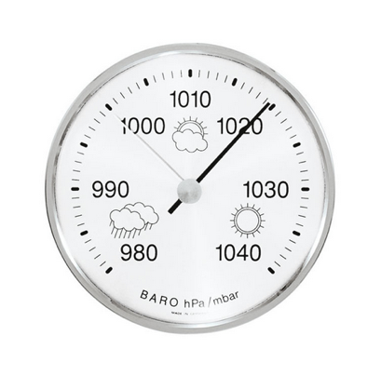 | Wind
The movement of air outside | Anemometer
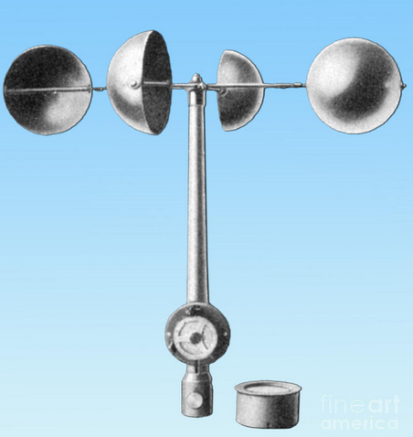 | 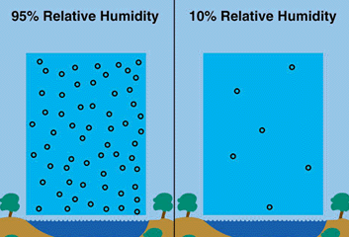
 | Clouds
A mass of very small drops of water or ice that float in the sky | Cumulus
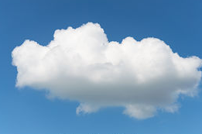 | Stratus
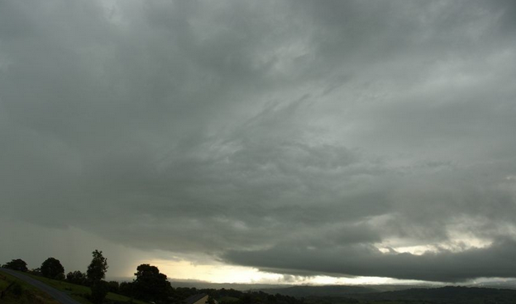 | Cirrus
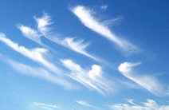 | Cumulonimbus
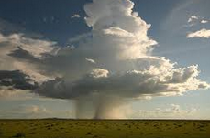 | Precipitation
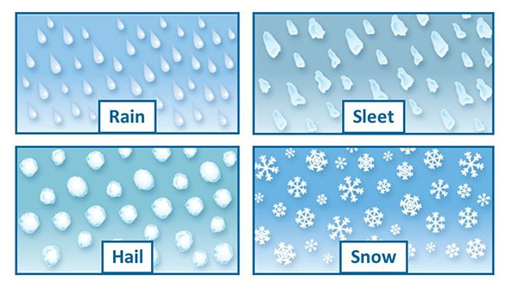 | 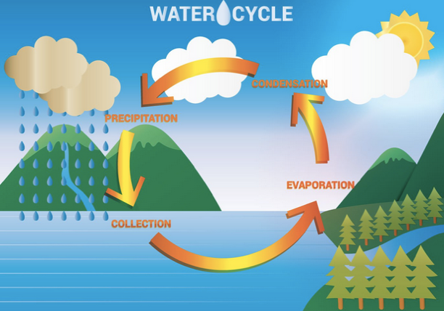
Water that falls from the clouds toward the ground.

