Name _______________________ Date __________
Wind

We will need:
Tissue paper
Scissors
Thumb tack
Thread
Desk Lamp

Procedure:
Cut the spiral shape out of tissue paper.
Poke a small hole in the center of the spiral with the tack.
Use the hole to tie the thread to the spiral.
Turn the lamp on and hold the spiral 10 cm over the lamp.

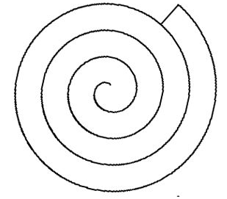

Hypothesis – What do you think will happen?

__________________________________________________________________________________________

__________________________________________________________________________________________

Observations:
Write about it:

__________________________________________________________________________________________

__________________________________________________________________________________________

Conclusion – Why do you think this happened?

__________________________________________________________________________________________

__________________________________________________________________________________________

